Software Requirement Analysis (SRS)
Project Title: SMART GRIEVANCE TRACKING SYSTEM
Department: Computer Science and Engineering
Scope: III Year CSE C 23CS178

Introduction
Purpose
The purpose of this project is to design a web-based Smart Grievance Tracking System that enables users to register complaints online, track their status in real-time, and ensure faster resolution through an organized digital platform. Currently, grievance handling is mostly done manually through paper forms, emails, or unstructured communication, which leads to delays, lost complaints, lack of transparency, and inefficient monitoring.
The proposed system allows users such as students, employees, or citizens to submit grievances, categorize issues, and receive a unique tracking ID for each complaint. The system automatically forwards grievances to the concerned authority and updates the progress status such as Pending, In Progress, and Resolved.
The platform also includes an admin dashboard for monitoring complaints, assigning responsibilities, prioritizing urgent issues, and generating reports. This improves accountability, transparency, and communication between users and authorities.
The system focuses on reducing manual workload, improving response time, preventing grievance loss, and providing a structured digital grievance management solution. The final output includes real-time tracking, digital complaint records, status notifications, and an efficient resolution mechanism. The scope is limited to a web-based grievance registration, tracking, and management system.
Scope
The system allows users such as students, employees, or citizens to register complaints through a centralized web-based platform. Users can specify the category of grievance, provide issue details, and upload supporting documents if required. Each grievance is assigned a unique tracking ID which helps users monitor the progress in real time.

The system intelligently prioritizes grievances based on urgency level, complaint type, and submission time, ensuring that critical issues are addressed first. Users can view status updates such as Pending, In Progress, and Resolved through their personalized dashboards.

Administrative users have access to a dedicated dashboard where they can manage complaints, assign grievances to concerned departments or staff, update progress, and generate reports for monitoring performance. Authorities can communicate responses and resolution updates directly through the system.

The platform also includes a grievance verification and feedback mechanism where users can confirm issue resolution and provide ratings for service quality. All complaint records are stored digitally to ensure transparency and easy retrieval.

The project is limited to a web-based grievance registration, tracking, and management system using temporary or development-level data storage. It does not include mobile application support, real-time chat assistance, or AI-based complaint prediction in the current scope.

Definitions
Grievance refers to a complaint or issue submitted digitally by a user regarding problems related to services, facilities, or administration. Each grievance is recorded in the system with a unique tracking identification number for monitoring and resolution.
Tracking ID refers to the system-generated unique reference number assigned to every grievance, which allows users to track the real-time status and progress of their complaint.
Priority Level refers to the classification of grievances based on urgency such as High, Medium, or Low, helping administrators resolve critical issues faster.
Status Update refers to the current stage of grievance processing such as Pending, In Progress, Resolved, or Closed.
User refers to the registered individual (student, employee, or citizen) who submits grievances, monitors complaint progress, and provides feedback after resolution.
Administrator refers to the authorized system authority responsible for managing grievances, assigning tasks, updating complaint status, and generating reports through the admin dashboard.
Department/Authority Module refers to the interface where concerned staff receive assigned grievances, take action, and update resolution details.
Feedback System refers to the mechanism that allows users to rate satisfaction after grievance resolution to improve service quality.

2. Overall Description
Product Perspective
The system is developed as a web-based grievance management application designed for users, administrators, and concerned authorities, supported by a centralized database structure for storing user details, grievance records, status updates, and resolution history. The platform follows a modular architecture where user registration, grievance submission, grievance prioritization, status tracking, and administrative management operate as independent but interconnected components.
The grievance prioritization module acts as the core processing unit that categorizes and ranks complaints based on urgency level, grievance type, and submission time, ensuring faster resolution of critical issues. The system is designed to be scalable so that advanced technologies such as AI-based complaint classification, automated response systems, mobile application support, and real-time notifications can be integrated in the future.
Administrative access is provided for monitoring grievances, assigning complaints to departments, updating resolution progress, and generating analytical reports. Authority-level access focuses on handling assigned grievances and updating action details, while user access is limited to complaint submission and tracking.
The system integrates principles of Object-Oriented Analysis and Design (OOAD) for structured module development, Software Project Management (SPM) for organized implementation, and Software Testing (ST) techniques to ensure reliability, security, and performance.
Product Functions
The system will support user registration with interest selection, intelligent course recommendation and prioritization, online skill assessments, automated certificate generation, and digital badge awarding. It will allow administrators to create and manage courses, define certification rules, and monitor user progress.
The system will ensure secure generation of certificates with unique verification identifiers and provide a verification interface for recruiters to validate authenticity. Course information will be presented in structured dashboards, and certificates will be available for download in digital formats. The platform ensures an organized, efficient, and credible skill certification process.
User Characteristics
The primary users of the system are students who possess basic computer literacy and seek to develop skills through online courses and certifications. They require an intuitive interface with clear navigation, personalized recommendations, and easy access to assessments and certificates.
Administrative users require moderate technical familiarity to manage course data, certifications, and user information. Recruiters are secondary users who require a simple verification interface to authenticate certificates. The system design prioritizes clarity, usability, and informative feedback messages for all user types.
Constraints
The system is currently implemented as a web-based application using temporary data storage during development. Certification generation must ensure uniqueness and prevent duplication of verification identifiers. Performance efficiency is required to load and prioritize course data within acceptable response times.
The platform does not include real-time instructor interaction, live video hosting, or mobile application support in the current scope. The project is developed for academic purposes and is not intended as a production-level commercial deployment.
Assumptions
It is assumed that course data is accurately provided and managed by the administrator. Users are expected to enter valid registration information and actively participate in assessments. External course listings are treated as informational references and do not directly host learning content within the platform.
Internet connectivity is assumed for system access, and system usage is limited to authenticated users. Future scalability enhancements are assumed to incorporate persistent databases and intelligent recommendation algorithms.

3. System Requirements
Functional Requirements
User Registration and Profile Management
The system shall allow users to register by providing personal details and selecting their areas of interest. It shall validate input fields, prevent duplicate email registrations, and securely store user information. A confirmation message shall be displayed upon successful registration. Only authenticated users shall be allowed to access personalized dashboards.
Course Management
The system shall allow administrators to add, edit, and delete course information including course category, difficulty level, duration, certification availability, and badge eligibility. It shall organize courses in structured formats and ensure all required fields are provided before saving. Only validated course entries shall be displayed to users.
Smart Recommendation Engine
The system shall analyze user interests and prioritize all available global courses accordingly. It shall display beginner-level and easy-to-complete courses first while maintaining access to all courses. The recommendation logic shall dynamically update when user interests are modified. Course ranking shall be generated automatically upon user login.
Assessment Management
The system shall allow users to attempt online multiple-choice assessments for selected courses. It shall validate submitted answers, calculate scores automatically, and determine pass or fail status. Only users who successfully complete assessments shall be eligible for certification and badge awarding.

Certificate Generation
The system shall automatically generate digital certificates upon successful course completion. Each certificate shall contain a unique verification identifier, user name, course name, and completion date. Certificates shall be available for download in digital format. Duplicate certificate identifiers shall be prevented.
Digital Badge Awarding
The system shall issue digital badges for completed skill tracks or milestone achievements. Badges shall be displayed visually in the user dashboard. Badge eligibility rules shall be configurable by administrators.
Certificate Verification
The system shall provide a verification interface for recruiters to validate certificates using unique verification IDs. It shall display certificate authenticity details including user name, course name, and issue date. Invalid or fake certificate entries shall return appropriate error messages.
Non-Functional Requirements
Performance
The system shall load course listings and generate prioritized recommendations within three seconds under normal usage conditions. Assessment processing and certificate generation shall occur in real-time without noticeable delay. System responsiveness shall remain stable across user modules.
Reliability
The system shall prevent certificate generation without successful assessment completion. Data consistency shall be maintained for user records, course information, and certification data. The system shall handle invalid inputs gracefully without crashing.
Usability
The system shall provide a clean and intuitive user interface with clear navigation paths. Error messages shall be understandable and actionable. Users shall be able to access core functionalities with minimal learning effort.

Scalability
The system shall be designed to support expansion to large user bases and integration of persistent databases in future implementations. Modular architecture shall allow additional learning modules, recommendation algorithms, and verification enhancements.
Security
Only authenticated users shall access personalized and administrative functionalities. User credentials shall be protected using secure authentication mechanisms. Certificate verification data shall be protected from unauthorized modification. Administrative actions shall be restricted and traceable.
Maintainability
The system shall follow modular design with separate user management, recommendation, assessment, and certification components. Code structure shall support easy updates and debugging. Future feature additions shall not disrupt existing system workflows.

4. Object-Oriented Analysis and Design Overview
Main Classes
● User
● Student Profile
● Course
● Assessment
● Certificate
● Digital Badge
● Recommendation Engine
● Admin
● Verification Request
● Certificate Manager
● UserManager
● CourseManager

Core Relationships
● User registers StudentProfile
● StudentProfile selects Course
● Course contains Assessment
● User completes Assessment
● CertificateManager generates Certificate
● DigitalBadge awarded to User
● RecommendationEngine prioritizes Course
● Admin manages Course
● Recruiter verifies Certificate

5. Use Case Overview
Primary Actors: Student, Administrator, Recruiter
Main Use Cases:
● Register User
● Login User
● Select Interests
● View Recommended Courses
● View All Courses
● Attempt Assessment
● Generate Certificate
● Earn Digital Badge
● Download Certificate
● Manage Courses (Admin)
● Manage Users (Admin)
● Verify Certificate (Recruiter)
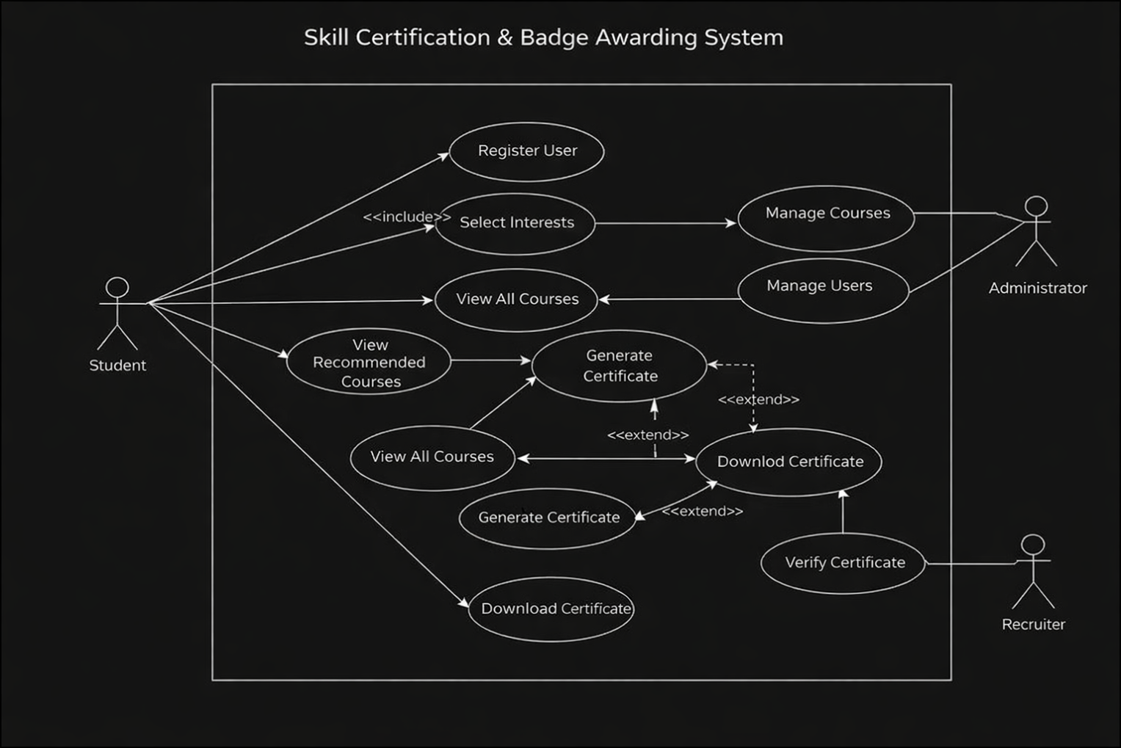
Use case diagram

6. Software Project Management Considerations
The project identifies potential risks such as incorrect user data entry, improper course categorization, recommendation logic errors, and certificate generation failures. Performance delays may occur during course prioritization or certificate processing under high user activity. Risk mitigation includes structured input validation, predefined course templates, automated recommendation testing, and unique certificate ID generation mechanisms.
Effort estimation focuses on frontend interface development, recommendation engine implementation, assessment module creation, and certification workflow integration. Additional effort is allocated for testing automation and system validation. Performance targets guide efficient data handling and sorting algorithms.
Controlled project scope prevents unnecessary feature expansion such as live video hosting or real-time mentoring. Structured planning and modular development ensure timely academic completion and maintain system quality.

7. Software Testing Strategy
Unit Testing
● User registration and input validation testing
● Recommendation engine logic testing
● Assessment scoring and result validation testing
● Certificate generation uniqueness testing
● Badge awarding rule testing

Integration Testing
● User registration to recommendation engine integration
● Course selection to assessment module integration
● Assessment completion to certificate generation integration
● Certificate generation to verification module integration

System Testing
● Complete user workflow from registration to certification testing
● Smart course prioritization flow testing
● Badge awarding functionality testing
● Certificate verification process testing
● Admin course management workflow testing

Selenium Testing
Automated UI testing will be performed using Selenium for:
● User registration and login functionality
● Interest selection interface behavior
● Course listing and recommendation display
● Assessment submission workflow
● Automatic certificate generation process
● Digital badge display and dashboard updates
● Certificate download functionality
● Recruiter certificate verification page
Selenium will validate that user interface workflows function correctly under real browser conditions and that the system responds appropriately to both valid and invalid user inputs.

8. Conclusion
The Skill Certification & Badge Awarding System is a web-based intelligent learning and certification platform designed to automate skill validation, enhance personalized learning, and ensure credible digital certification. The system integrates principles of Object-Oriented Analysis and Design for modular architecture, Software Project Management for controlled development and risk handling, and Software Testing methodologies including Selenium-based automated UI testing to ensure reliability, accuracy, and usability.
The platform provides smart global course recommendations, automated certificate generation, digital badge recognition, and recruiter verification, offering a scalable and modern solution for skill development. The scope is limited to a web-based academic implementation with future expansion potential.

